Quiz App with GUI using Python

SDP project by Omkar Kulkarni

Abstract- Quiz App is an app which provides a platform to conduct quizzes, MCQs test, survey, etc. With the use Tkinter library of python, Graphical User Interface is provided that gives ease of handling for the user. The app is programmed in such a way that it will allow an examiner to set the quiz or test with customized questions, options, timer, score, etc. Tkinter, datetime and json are few open source python libraries which are used in the project
Keywords- Quiz, GUI, Python, Tkinter, MCQs

INTRODUCTION
After the invention of printer, use of papers has surged up in the last century. In all basic means of communication paper played a major role. From personal letters to newspapers to books, everything is made from papers. In the field of education paper is literally almost everything. Teachers teach students from books, students write on books, tests are conducted on papers and so on.
Paper playing such an important role for mankind is made from another important thing for mankind’s survival, that is trees. So, the use of paper directly impacts cutting down of trees. More you use paper more trees are cut down, thus inviting more of environmental problems. Although not all papers become waste after their use. To look on positive side, nowadays waste papers are being recycled. This reduces impact of paper on environment very much.
In today’s world as digital devices such as computers, laptops, phones, etc. have become common we can look forward to completely eradicate use of papers that will even reduce the energy usage in recycling of wastepaper. We can already see use of e-books has reduced use of hardcopy books very significantly. Similarly, we can attempt to create an app which will provide MCQ testing platform that will reduce the use of paper needed for tests.
We are aiming at providing an easy-to-use testing platform which will automatically generate evaluation report thus reducing human resource required for the same.

OBJECTIVES
Firstly, the application was supposed to be provide an easy-to-use platform. A GUI was needed to fulfill the first objective. Different logins were to be provided for admin or examiner and student or examinee. Tests and students adding feature provided for the admin. Shuffled questions and options during test was an important objective to be achieved. Direct report generation of evaluation on completion of test or examination. Keeping records of all the tests given. These are some of the objectives that were to be achieved in the desired application.

TOOLS USED
Major tools used for the app development are VS Code, Python language and MySQL database. VS Code was used for coding ide and MySQL was used to store data in ROM for long time storing purpose.
In python, Tkinter library was used to create GUI for the application. Threading library was imported for creating a tread for timer during the quiz. Random library was imported for shuffling the questions as well as options to decrease chances of malpractices.

RESULTS
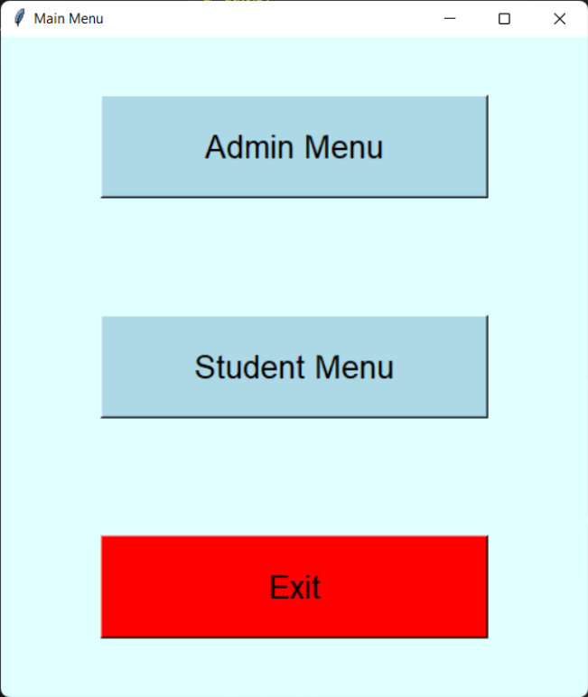
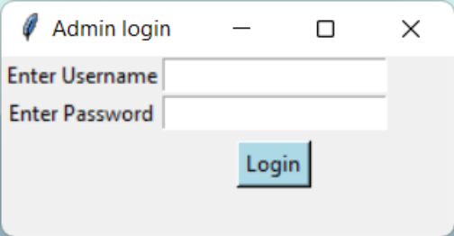
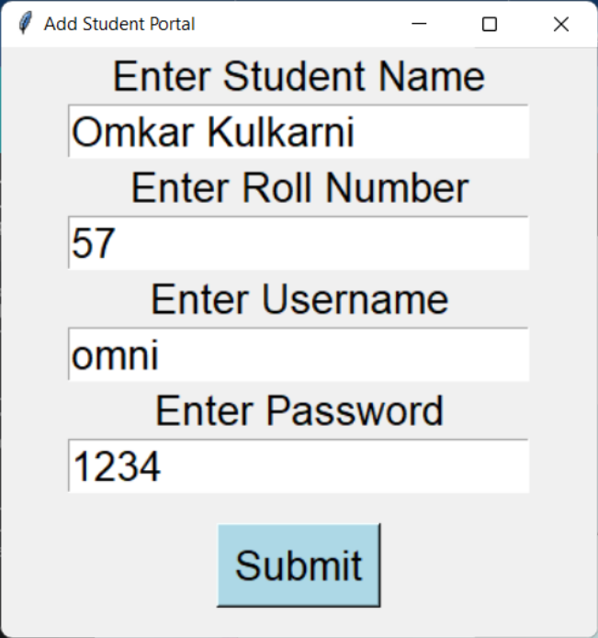
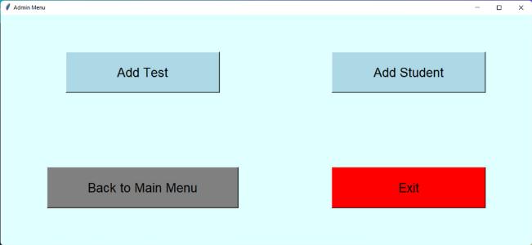
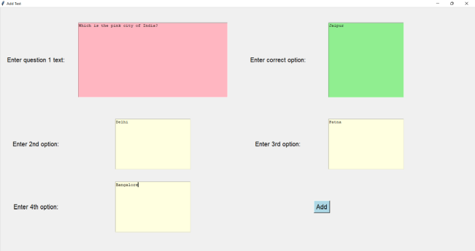
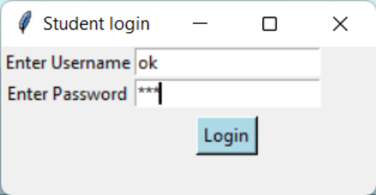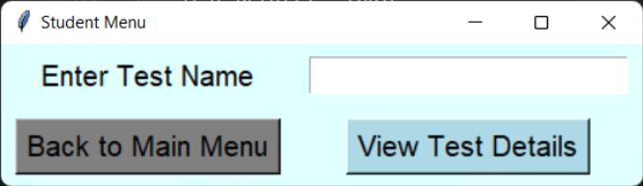
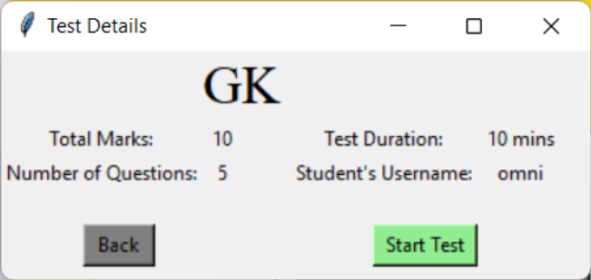
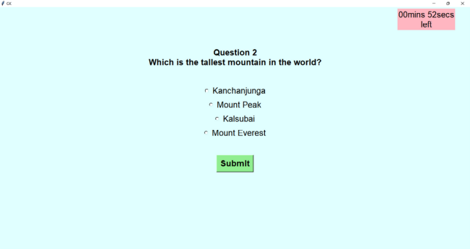
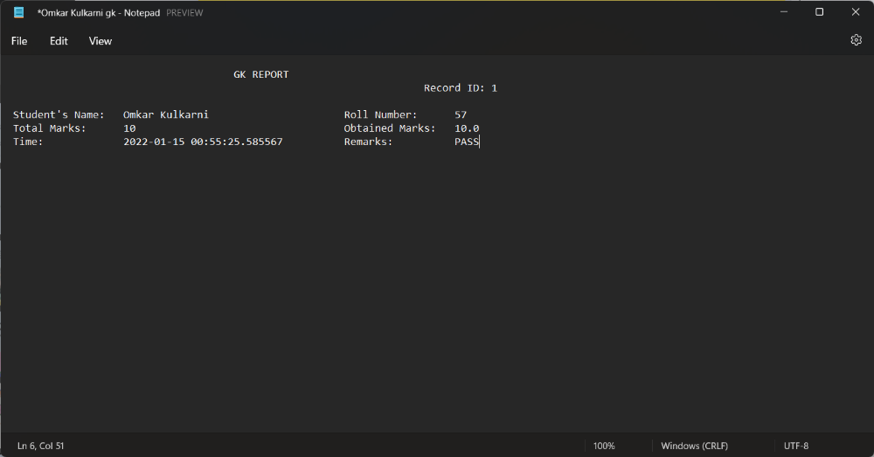

REFERENCES
- https://docs.python.org/3/library/threading.html
- https://docs.python.org/3/library/random.html
- https://docs.python.org/3/library/tkinter.html

